
Lab Program Number: 31 Date: 17th March,2026
Title: Firewall Configuration

- Install “firewalld” package and start the service.
Command:
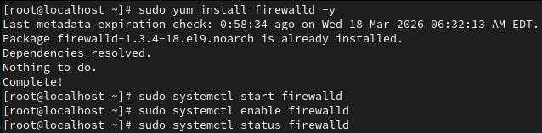
Output:
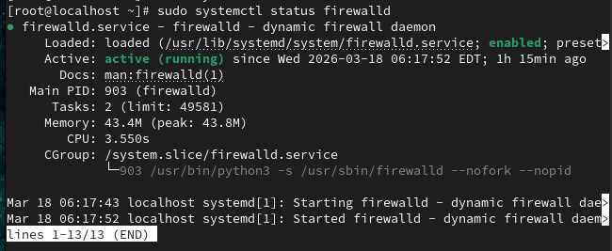

- Add the following services and ports to allow packets through the firewall.
[service = http, smtp port = 25/tcp, 25/udp, 110/tcp]
Command:
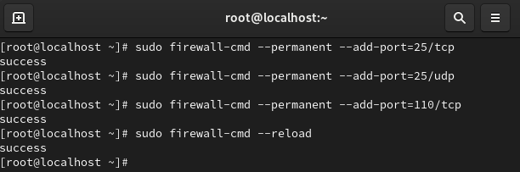
Output:
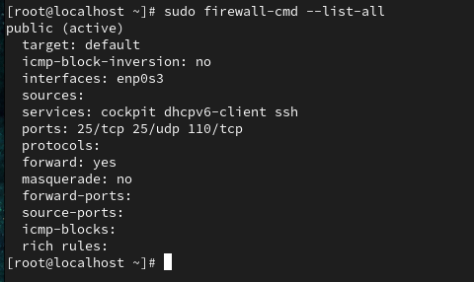

- Remove the following service and port to block packets through the firewall.
[ service = smtp, port = 25/tcp , 25/udp]
Command:
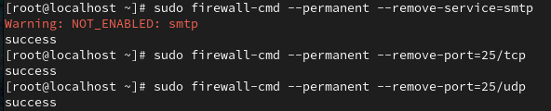
Output:
